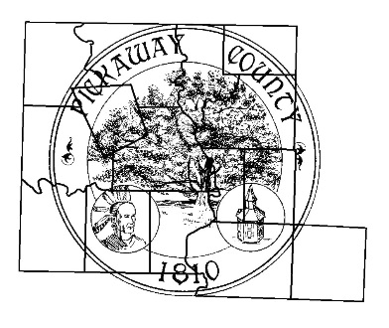
Washington Township, Pickaway County, Ohio

APPLICATION FOR PERMIT TO WORK ALONG OR ACROSS Washington Township, Ohio roads

Application Date: __________________ Permit #: Wash.TWP______

Application is hereby made by ______________________________________________________________________________
Address or P.O. __________________________________________________________________________________________

Complete of work to be done: _____________________________________________________________________________
_______________________________________________________________________________________________________
_______________________________________________________________________________________________________

AT THE FOLLOWING DESCRIBED LOCATION:
Along/across _____________________________________ Road, ______________________ Township.
Work will commence on or about __________________________ and will require __________ days.

If this permit is granted, I/We agree to the following conditions:
- The traffic will be maintained at all times, unless written permission is granted by the Washington Township Trustees to close the road.
- The disturbance to road surface and shoulders will be kept at a minimum and trenches will be backfilled with gravel and tamped so that settlement of the material will be minimized. If settlement does occur, additional suitable material will be put into place and compacted.
- The road surface at the trench will be replaced with material of the type that was removed and the new surface shall conform with the grade of the undisturbed surface.
- Lights, signs, barricades and, if necessary, flaggers and watchmen will be placed on the job for the protection of traffic at all times, day and night, during the time this work is being done and instructions given by the Washington Township trustee (representative), as to handling of traffic, will be fully complied with.
- I/We assume the responsibility for and will save Washington Township harmless from any and all claims for personal injuries and property damages and shall defend any action that might be brought due to this work. To cover this responsibility, I/we have the following insurance (Minimum of $2 Million per occurrence) which is now in force and will remain in force during the prosecution of this work:

AMOUNT | FOR | POLICY NUMBER | INSURANCE CO.

- Permit Responsibility will remain in force until a release has been granted the Washington TWP. Trustee (Representative).
- Please provide a copy of complete plans for your intended project with this application to Washinton Township Trustees 8151 Stoutsville pike Circleville, Ohio 43113, Phone Number: 740-497-2020, e-mail: WashingtonPickaway@frontier.com
- Washington Township must be notified 48 hours prior to beginning work.
- A right of way request is required, and a verified right of way must be shown on the submitted plan.
- Locations of pole and/or underground junction boxes shall be marked with wooden laths. These laths will be marked as to the corresponding pole/box number on it. Locations must be approved by the Trustees prior to installation.
IF APPROVED, PERMIT EXPIRES 90 DAYS FROM PERMIT APPROVAL DATE, UNLESS OTHERWISE NOTED BY Washington Township Trustee (representative)

Applicant Name: __________________________ Trustee (representative)Signature: _____________________
Applicant Signature: _______________________ Approval Date: _______________________________
Applicant Address: ________________________ Applicant Phone Number: _______________________

